|  |  |
| --- | --- |
| **Project** | Desoutter CC – Pivotware Demo Plugin |
| **Title** | Custom Plugin - Plugin Demo 1 – Api v2 |
| **Customer Delivery Date:** | 25/01/2018 |

Version Control

|  |  |  |  |
| --- | --- | --- | --- |
| **Version** | **Date** | **Author** | **Description** |
| 1.0 | 25/01/2018 | X. Richard | Initial version |
|  |  |  |  |

# General Description

This plugin is a demo plugin using keyboard, traceability, logs from plugin Api v2 and serial communication.

# Plugin Presentation

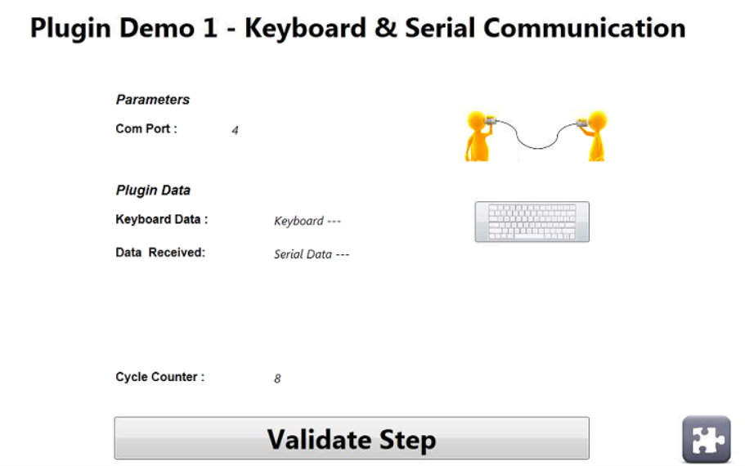

In order to use the plugin, the station must be connected to a laptop/PC using a serial cable (use COM1,2,3 or 4, serial com port number is defined in plugin parameters).



If user click on then a keyboard is displayed. The user can enter a value he wants and validate it with “OK” button. When the value is validated, it is displayed on plugin screen and sent via the serial connection to the laptop/PC connected to the Infinity station.

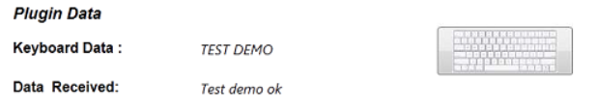

If laptop/PC sends a serial frame to the Infinity station, the data are displayed on plugin screen.

Each time the plugin starts, the “Cycle Counter” value is incremented by 1.

If the user click on “Validate Step” button the plugin ends.

# Plugin Parameters

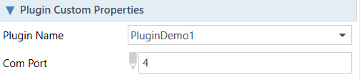In Fusion, you have to setup the serial com port used by the plugin.

# Plugin Troubleshooting

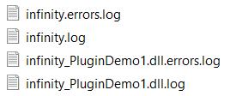Plugin logs are available in ***C:\Pivotware\logs***

***infinity.log*** and ***infinity.errors.log*** contain plugin management logs by Infinity

***infinity_PluginDemo1.dll.log*** and ***infinity_PluginDemo1.dll.errors.log*** contain specific logs from the plugin